學思達講義 2000單 U6 Journal日誌 Name:____________ No._____
Group Members: 1.________2.________3.________4._______5._______

Task 1 Think about the following questions: (5 minutes)
- Have you ever kept a journal/diary before? _______________________________
- Read a page from the book “Diary of Wimpy Kid葛瑞的囧日記”.
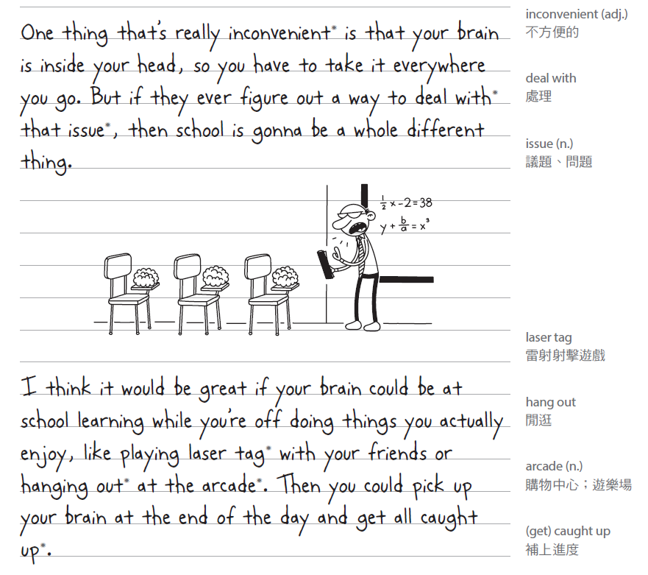

What information(資訊) could you get from the passage? Please check in the □.
□Wimpy’s feeling □Wimpy’s daily events at school
□Wimpy’s ideas □Wimpy’s creative writing
□Wimpy’s sketches □Wimpy’s plan

Additional Information補充資料:
- A diary(日記) is usually used to record daily events(事件) and feelings, while a journal(日誌) is more flexible(彈性的) and can include thoughts, ideas, sketches(插圖), or plans.

Task 2 Self-Study Read and learn some new vocabularies (15 minutes)
- Read P47-U6-Jason’s journal carefully.
- Underline the words you don’t know.
- Use the vocabulary table below to help you learn some new words.
Match the following 8 new words to their Chinese and English meaning and also highlight the key words that help you to understand the new words better.
 | 緊張的(adj.) |  | 假定;認為(v.) |  | 簡單的(adj.) |  | 閒晃(phr.)
 | 和…比較(v.) |  | 覆蓋;遮住(v.) |  | 驕傲的;自豪的(adj.) |  | 日誌(n.)
Word |  | 中文意思 |  | Meaning |  | Example Sentence
journal |  |  |  | a book to write your thoughts or daily events |  | I write in my __________ every night.
nervous |  |  |  | feeling worried |  | I feel nervous before a test.
compare |  |  |  | to see how things are different or the same |  | I feel short compared to my classmates.
assume |  |  |  | to think something is true |  | She _________ it will rain later.
simple |  |  |  | easy to do or understand |  | This question is very simple.
hang out |  |  |  | to spend time with friends |  | I like to hang out with my friends after school.
cover |  |  |  | to hide or protect something |  | I cover my answers during the test.
proud |  |  |  | feeling good about yourself |  | She felt proud of her painting.



- More practice: write some other words that you also don’t know from P47 and find their Chinese meaning from P48 to P51. For each word, write the vocabularies, its Chinese meaning, English meaning and a simple sentence.
New vocabularies | Chinese meaning | English meaning | Make a sentence
grade | 年級 | A level in school that shows the year or age group of students. | I’m in seventh grade.

Task 3 Discuss the questions about P47-Jason’s journal in pairs. (15 minutes)

Find the key sentence in the passage(文章) to help you answer the questions below.

Why is Jason nervous in Week 1? _____________________________________________________
- How does Jason feel about Ray in Week 2? _____________________________________________
- Why does Jason want to change seats in class in Week 3? ________________________________________________________________________________
- What makes Jason happy in Week 4? __________________________________________________
- Why does Jason think Ray and he can have a good friendship?
________________________________________________________________________________
- If you were Jason, what would you do about Keith? ______________________________________
- Do you have a friend like Ray? And how this friend helps you in school? _____________________

Hi everybody, I’m ___________. We’re going to talk about question number ___.
My partner thinks that if he/she were Jason, he/she would ______________________________________.
And yes, he/she has a friend like Ray, and this friend helps him/her ______________________________.
OR No, he/she doesn’t have a friend like Ray, but he/she believes that __________________________.

Task 4 Extension Activity:
- Read the following chart using ORID(焦點討論法) to describe(描述) Jason’s Journal in four different ways. And follow the instructions(指示) to create(創造) your ORID toward a school event.
Objective:客觀事實(根據事實寫下發生的事情)  - What grade does Jason start in school?  O  Jason starts seventh grade.  - Who is Jason’s new friend? What do they both like? Jason’s new friend is Ray, and they both like baseball.  - Why was Jason happy in Week 4?  Jason was happy because Mr. Johnson used his homework as an example, and Keith was moved to another seat. | Reflective:反思(寫下自己對事件的感受與情緒)  1. How do you think Jason felt when Keith copied his work? Jason felt annoyed.  R  2. Why do you think Jason felt proud when Mr. Johnson used his homework? Jason felt proud because it showed that his work was good.  Jason’s Journal
Decisional:未來的決策與行動  1. What would you do if someone like Keith copied your work? I would politely ask them to stop and talk to the teacher if it continued.  D  2. If you were Jason, how would you make more friends at school?  I would try to talk to classmates, join activities, or ask if they want to play games or study together. | Interpretive:詮釋事件發生  (學到了什麼?發現了什麼?)  I  1.What does Jason’s journal tell us about his new life in school? Jason was nervous and had some troubles to make friends at first. He made new friends like Ray, and kept working hard in class.  2.How did Jason’s feelings about school change from Week 1 to Week 5?  In Week 1, Jason felt nervous about new school, but by Week 5, he felt happy and confident, especially about his friendship and learning English.
- Homework: Base on the ORID (焦點討論法) above, complete your ORID chart toward a school event when you felt proud or nervous. Use at least five new words from today’s lesson and highlight them in the chart.

Objective:客觀事實(根據事實寫下發生的事情)  What happened to you during the school event?  O  _________________________________________  _________________________________________  Who was involved in the event?  _________________________________________  _________________________________________ | Reflective:反思(寫下自己對事件的感受與情緒)  Were you nervous, excited, or proud during the event? Or any other feelings toward this event?  R  _________________________________________  _________________________________________  What was the most important part of the event of you? _____________________________________  _________________________________________  A school event:
Decisional:未來的決策與行動  What will you do next if the same thing happens again?  I will_____________________________________  _________________________________________  How will this experience help you in the future?  _________________________________________  _________________________________________ | Interpretive:詮釋事件發生  (學到了什麼?發現了什麼?)  I  What did you learn during this event?  I learned that _____________________________  _________________________________________  _________________________________________  What did you find from this event?  I found that _______________________________  _________________________________________  _________________________________________
Fun Fact:
Did you know keeping a journal can help improve your English writing skills and your memory?

