學思達講義康軒B3 L2 Why Didn’t You See a Doctor (Voc.) Name:______ No._____
Group Members: No.1_____/No.2____/No.3_____/No.4_____
⭐⭐⭐⭐⭐⭐⭐⭐⭐⭐⭐⭐⭐⭐⭐⭐⭐⭐⭐⭐⭐⭐⭐⭐⭐⭐⭐⭐⭐⭐⭐⭐⭐⭐⭐⭐⭐⭐⭐⭐⭐⭐⭐
Task 1 Preview Before starting the lesson, please preview all the vocabularies in Lesson Two first. Open your student book to P.118 and write down the words you already knew and the words you want to know. (5 minutes)
Knew | Want to know
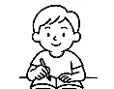
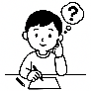
Task 2 Write Please find out all the meanings of the bold words from the reading below and write the Chinese translation on the line. (See SB P.118)
A Bad Day, A Strong Heart
Last Monday morning, I woke up (__________) with a terrible headache (頭痛). My throat was dry, and my stomach (__________) was hurting badly. I looked in the mirror. My hair was messy (__________), and my face looked tired.
My mom saw me and said, “You look sick (__________). Take your medicine (__________) and put on (__________) your coat (__________). You shouldn’t go to school.”
“But I have to!” I said. “We have a group project about health (__________) today!”
At school, my friend Kevin asked, “Why (__________) didn’t you stay home (__________)?”
I said, “I caught a cold (__________), but the project is too important.” During class, I tried to speak (__________), but my throat (__________) hurt. Kevin helped by calling our group members. He even sent (__________) them a message (__________) about what to do.
When I got home, I felt worse. My legs and arms (__________) were weak, and my knees (__________) were shaking. My neck (__________) was sore, and even my toes (__________) hurt. I lay in bed with a mask (__________) on, thinking: "Why am I always the one to get sick?" But then I remembered Kevin’s words: “You’re strong for coming to school.”
Later, my cousin sent me a card and some ice cream. That made me feel better. I also got a message (__________) from my teacher. She said, “You tried your best (__________). That’s what really matters.” Now, I always try to stay healthy (__________). I eat better food, wear warm clothes (__________), and get enough sleep. I also learned how to treat (__________) a cold and be more serious about my body.
Maybe (__________) getting sick was bad, but it also taught me to be thankful. As for (__________) my next school project—I'm ready!
Task 3 Group the words Please put the words from this lesson into the table. Group them by what kind of word they are, like noun, verb, or adjective. (See SB P.118)
Noun (N.) | Verb/Verb Phrase | Adj. | Prep./Conj./Phr. /Adv. & Others
Task 4 Listen Please look at the words on P.118 and mark the syllables. Show how many parts the word has when you say it. Listen to the teacher and mark at the same time.
Example of the syllables:
shoul|der | fe|ver | may|be
Challenges: Read the words below and find out how many syllables they are.
message | health | serious
medicine | healthy | stomach
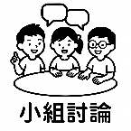
Task 5 Read Please read the passage in Task 2 to your partner and ask him or her to sign their names as confirmation.
★Highlight the words that you don’t know how to read.
I read the reading above to my classmate, ___________.
Signature: _________________________

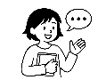
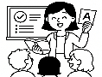
Task 6 Create Choose five words that you are not familiar with on P.118 and create your own story with those words. When you write, check the form(詞性) of the word in the chart in Task 3. Then, share your story in class.
Tips (小提醒):
- When you use a word, check what kind of word it is.
👉 Is it a noun (a person, place, or thing)?

- Think about the tense in your sentence.
👉 Are you talking about now, before, or later?

- Please write a complete sentence and make sure it makes sense in your story.
This will help you write good sentences and use new words the right way!

My Story --___________________________________________

_________________________________________________________________________
_________________________________________________________________________
_________________________________________________________________________
_________________________________________________________________________
_________________________________________________________________________
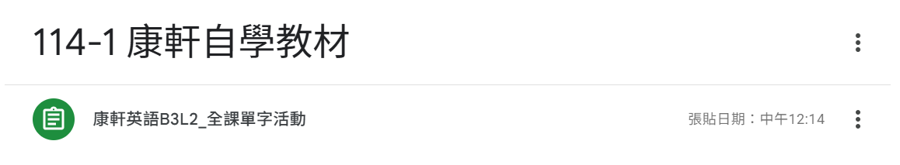
Task 7 Homework Complete the vocabulary practice on Quizlet. The link is in Google Classroom.

Task 8 Self-Check – What did I learn?
☐ I understand all the new words in Lesson 2 and how to use them
☐ Some words are still unfamiliar to me. They are: _______________________________________________.
☐ I know the word type (noun, verb, adjective, etc.) for each one.
What strategy helped me learn the words best?
☐Saying the words out loud ☐Writing my own sentences
☐Using Quizlet ☐ ______________________
Something I learned about the words.
(For example: I learned how to read the new words. or I discovered some words have more than one meaning.)
👉 ______________________________________________________________________.

