學思達講義 康軒B1 L3 Let’s Get Some Ideas from RoomGPT Name:____________ No._____
Group Members: Leader____ Speaker_____Writer____Examiner___


Task 1 Create(________) your makeover(_________) room and talk about it. (20 mins)
- Follow the 4 steps(__________) to create your makeover room.

- Step 1: Watch the video of RoomGPT introduction(____________) and write 3 steps from the website about redesigning(____________) a room.
First step
Second step
Third step

RoomGPT : https://www.roomsgpt.io/en

Then, follow the steps above to create your own makeover room.

Here is the list of some common styles on the website.
Modern：現代 | Earthy：大地色 | Luxury：奢華
Neutral：中性 | Bright：明亮 | Urban：都市風
Monochromatic：單色 | Tropical：熱帶風 | Industrial：工業風
Complementary：互補 | Bold：大膽 | Coastal：海岸風
Warm：暖色 | Traditional：傳統 | Baroque：巴洛克風
Cool：冷色 | Organic modern：有機現代風 | Sketch：素描風

Download the new picture of your new room.
- Step 2: Upload the old style room picture on Padlet and write some sentences about it.
Leave a comment(__________) on your post with the makeover room picture.
The following is the example of the post and comment.
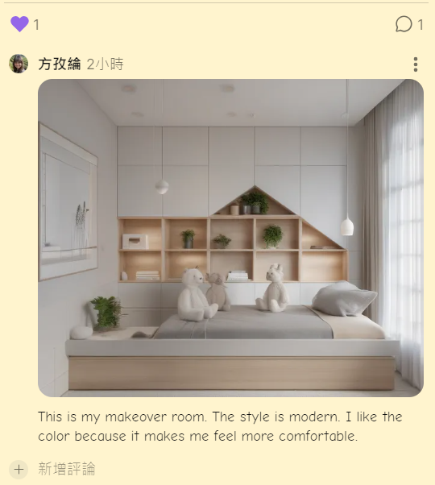
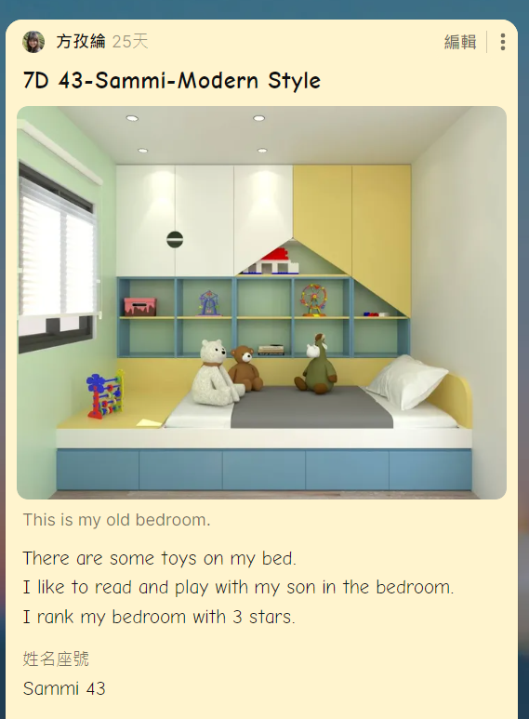

- Step 3: Find the classroom makeovers from your classmates that you like the most.
Please give some likes(讚) or suggestions for your classmates' makeovers on Padlet.
Example of a comment:
“I like your new style because it feels very chill and sweet.”
“I think your new design is very nice and simple.”
Task 2 Think Outside of the Box! (5 mins)
- How do you think about the RoomGPT website? Does it provide useful functions?
- What are some other AI tools that you know? Do they make your life different?


※Share your answers in pairs and express your idea.
Task 3 Read and Match (10 mins)
- Read L3 Dialogue from P43 to 44 and practice reading the new words in this unit.

- Match the word to its definition. Also, write down the Chinese meanings of each word.
 | 1. style | a. A big change in the way something looks to make it better.
a. 改造 | 2. makeover | b. A group of things that are the same in some way.
 | 3. tool | c. One action in a series(連串) to reach a goal
 | 4. step | d. The special way something is done, said, or made. It is how a person does things in their own way, like how they dress, write, or speak.
 | 5. type | e. The main idea or subject of something
 | 6. theme | f. Something you use to help to do a job.
※Check the answers in pairs.
Task 5 Role Play(角色扮演) (5 mins)
Read the dialogue from this lesson as a role-play with your pair partner.
Who plays Scott? __________ Who plays Bella? ___________
※When you read, please read with emotion(__________) and gestures(__________) and pretend(假裝) that you are Scott/Bella.
※Think and Write: What are the advantages(優點) of reading with emotion and gestures?
_________________________________________________________________________________
Task 6 Answer the questions below after reading L3 Dialogue. (15 mins)
- Does Scott like his home? Why or Why not?
____________________________________________________________________________
- Where is Bella’s smartphone?
____________________________________________________________________________
- What is RoomGPT?
____________________________________________________________________________
- Why does Scott mean when he says, “That’s a good question.”?
____________________________________________________________________________
Name:____________ No._____
- Create a dialogue that must use the response of “That’s a good question.”
A: __________________________________________________________________________
B: __________________________________________________________________________
A: __________________________________________________________________________
B: That’s a good question.
- After reading the dialogue(對話), make a good question on your own. (What is a good question?)
A good question needs to be:
a.____________ b. ____________ c. ____________ d. ____________
Write down your good question about the dialogue? __________________________________________
- Complete the question on P44.
※Check the answers in the group and present.
學思達講義 康軒B1 L3 Reading 文章閱讀 Beds
Task 1 Before You Read閱讀前: (5 mins)
- Look at the pictures on page 49. Are Jenny’s bed and Jason’s bed the same? | (Answer with completed sentence.)
- Look at the pictures on page 49. Where are Jenny’s and Jason’s bedrooms? | (Answer with completed sentence.)
Task 2:While You Read閱讀時(P49): (5 mins)
Here are some reading skills(技巧) for you:
Mark the unknown words or the words you can’t read on P49.
在課本P49標記出不認識或不會唸的單字。
Reading Skill- Guess the meaning: Use the context to guess the meaning of the words.
閱讀技巧- 猜測字義:藉由上下文猜測意思、重新閱讀再次理解。
The words that you can guess from the context.  寫下你藉由情境猜測出的單字。 | The words that you still can’t understand after reading.寫下你仍然不理解的單字。
Task 3 After You read閱讀後: Draw the Graphic Organization Chart(________) of L3 Reading.
Essential Question(核心問題) of the article:
How are Jenny's and Jason's beds different in terms of size and material?
______________________________________________________________________________________
Beds

Answer the following the questions:
- What’s the reading mainly about?
- Why do people live in an igloo or a cave?
- Make a good question of this reading.
- Finish the questions on P50.
※Check the answers in the group and present.

Task 4 Guess Which One is Your Classmate’s Room (10 mins)
Look at the picture on the screen. After listening to your classmate’s description(描述) of his/her room, try to guess which room it is.
Each student will take turns describing their room. Use terms like "in," "inside," "beside," "next to," "around," "on," and others to help describe the room.
At the end of each description, make your guess based on what you heard.
Additional Information補充資料:
Igloo:
An igloo is a small house made of snow and ice. People from the Inuit(紐特人) culture, who live in very cold places like Alaska and Canada, used to build igloos. They were warm inside because snow is a good insulator(__________). In the past, igloos were used by hunters to stay safe from the cold during trips. Today, some Inuits still use them for special purposes, but most live in modern(__________) houses.
How do I guess/know the meaning of insulator? Which sentence gives me the idea?
Cave:
A cave is a natural hole in the ground or in mountains. Long ago, before people had houses, early humans used caves for shelter(____________). They protected(保護) people from(免於) the weather, wild animals, and enemies(敵人). Caves were also used for religious(宗教的) ceremonies(儀式) or as burial(葬墓) sites(場地). Today, people don't live in caves, but they are visited by explorers or tourists. Some caves are famous for their beautiful formations(地形) or ancient(古代的) art.
How do I guess/know the meaning of shelter? Which sentence gives me the idea?
Task 5 Reflection反思: (5 mins)
Please tick the following statements that reflect what you have learned in today’s lesson?
- I can guess the meaning from the context.
- I can use the graphic organization chart to better understand the article.
- I can share my thoughts in groups.
- I know how to describe my own room using "in," "on," "under," "in front of," "next to," and "between.".
- I can encourage my classmate to express themselves.

